**Create a Flow-to-monitor-incoming-mails-Using-Power-platform**

**Step 1:** Sign in to Power Automate using this link - <https://flow.microsoft.com/>

**Step 2:** Select My Flows >> New Flows >> Automated Cloud flow

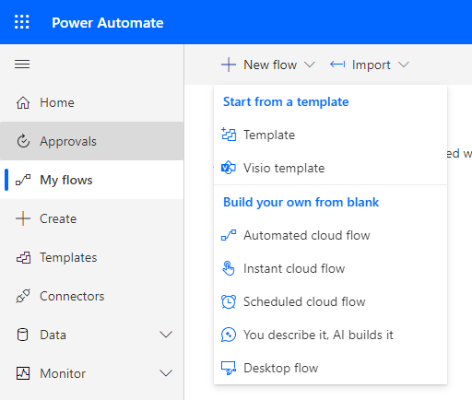

**Step 3:** Add a Flow name and select a trigger from the list to create a flow. Click on Create.

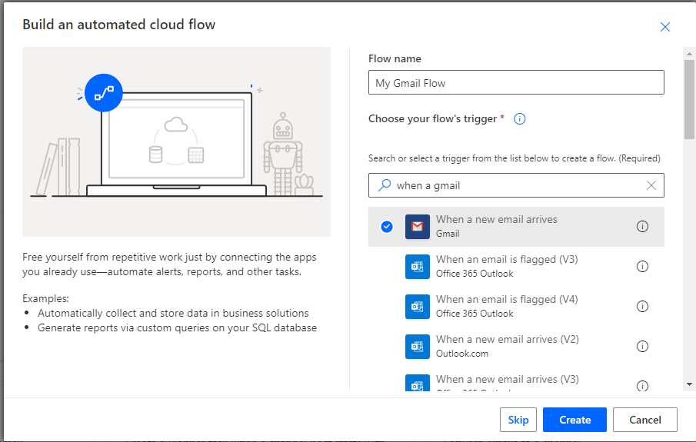

**Step 4:** Link to your Gmail Account and Click on Show advanced options  
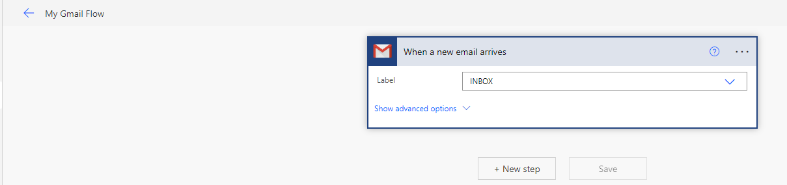

**Step 5:** Add the Email address you want to respond with an automatic email, then click on “New step”.

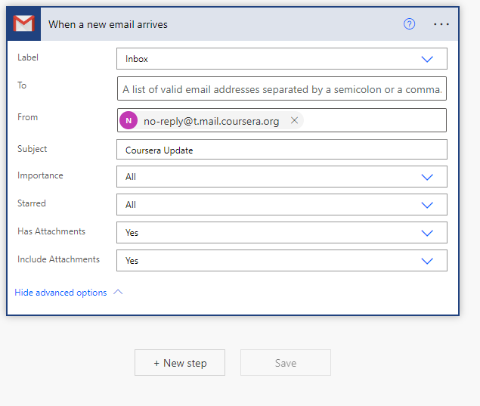

**Step 6**: Add a flow, by choosing any application of your choice in the next step options. Then set It up.

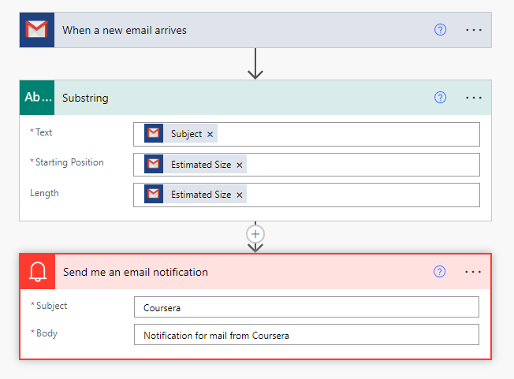

**Step 7:** Once complete you will get a notification your flow is ready to go.

